

# Semester 2019/2020 (A191)

**School of Computing, CAS, UUM**

**STIW2044: Mobile Programming**

**Lab 1: BMR Calculator**

Name: Nur Aini Syamimi Binti Md Rozilan

Matric No.: 245480

Phone No.: 01164471146

# Main.dart

import 'package:flutter/material.dart';

import 'labeledRadio.dart';

void main() => runApp(MyApp());

class MyApp extends StatefulWidget {

  @override

  _MyAppState createState() => _MyAppState();

}

class _MyAppState extends State<MyApp> {

  final TextEditingController _wcontroller = TextEditingController();

  final TextEditingController _hcontroller = TextEditingController();

  final TextEditingController _acontroller = TextEditingController();

  double height = 0.0, weight = 0.0, result = 0.0;

  int age = 0;

  String bmr;

  LabeledRadio radiobutton = new LabeledRadio();

  bool _isRadioSelected = false;

  @override

  Widget build(BuildContext context) {

    return MaterialApp(

      title: 'Material App',

      home: Scaffold(

        resizeToAvoidBottomPadding: false,

        appBar: AppBar(

          title: Text('BMR Application'),

        ),

        body: Center(

          child: ListView(

            shrinkWrap: true,

            children: <Widget>[

              LabeledRadio(

                label: 'Female',

                padding: const EdgeInsets.fromLTRB(100, 0, 100, 0),

                value: false,

                groupValue: _isRadioSelected,

                onChanged: (bool newValue) {

                  setState(() {

                    _isRadioSelected = newValue;

                  });

                },

              ),

              LabeledRadio(

                label: 'Male',

                padding: const EdgeInsets.fromLTRB(100, 0, 100, 10),

                value: true,

                groupValue: _isRadioSelected,

                onChanged: (bool newValue) {

                  setState(() {

                    _isRadioSelected = newValue;

                  });

                },

              ),

              Padding(

                padding: EdgeInsets.fromLTRB(100, 0, 100, 10),

                child: TextField(

                  decoration: InputDecoration(

                    hintText: "Age(year)",

                  ),

                  keyboardType: TextInputType.numberWithOptions(),

                  controller: _acontroller,

                ),

              ),

              Padding(

                padding: EdgeInsets.fromLTRB(100, 0, 100, 10),

                child: TextField(

                  decoration: InputDecoration(

                    hintText: "Height(cm)",

                  ),

                  keyboardType: TextInputType.numberWithOptions(),

                  controller: _hcontroller,

                ),

              ),

              Padding(

                padding: EdgeInsets.fromLTRB(100, 0, 100, 20),

                child: TextField(

                  decoration: InputDecoration(

                    hintText: "Weight(kg)",

                  ),

                  keyboardType: TextInputType.numberWithOptions(),

                  controller: _wcontroller,

                ),

              ),

              Padding(

                padding: EdgeInsets.fromLTRB(110, 5, 110, 5),

                child: RaisedButton(

                  child: Text("Calculate BMR"),

                  onPressed: _onPress,

                ),

              ),

              Padding(

                padding: EdgeInsets.fromLTRB(110, 5, 110, 5),

                child: RaisedButton(

                  child: Text("Reset"),

                  onPressed: _onPress1,

                ),

              ),

              Center(

                child: Text("BMR: $bmr"),

              ),

            ],

          ),

        ),

      ),

    );

  }

  void _onPress() {

    setState(() {

      weight = double.parse(_wcontroller.text);

      height = double.parse(_hcontroller.text);

      age = int.parse(_acontroller.text);

      if (LabeledRadio().label == 'Female') {

        result = (10 * weight) + (6.25 * height) - (5 * age) - 161;

      } else if (LabeledRadio().label == 'Male') {

        result = (10 * weight) + (6.25 * height) - (5 * age) + 5;

      }

      bmr = format(result);

    });

  }

  String format(double n) {

    return n.toStringAsFixed(n.truncateToDouble() == n ? 0 : 2);

  }

  void _onPress1() {

    setState(() {

      _wcontroller.text='';

      _hcontroller.text='';

      _acontroller.text='';

      bmr = '';

    });

  }

}

# LabeledRadio.dart

import 'package:flutter/material.dart';

void main() => runApp(LabeledRadio());

class LabeledRadio extends StatelessWidget {

  const LabeledRadio({

    this.label,

    this.padding,

    this.groupValue,

    this.value,

    this.onChanged,

  });

  final String label;

  final EdgeInsets padding;

  final bool groupValue;

  final bool value;

  final Function onChanged;

  @override

  Widget build(BuildContext context) {

    return InkWell(

      onTap: () {

        if (value != groupValue) onChanged(value);

      },

      child: Padding(

        padding: padding,

        child: Row(

          children: <Widget>[

            Radio<bool>(

              groupValue: groupValue,

              value: value,

              onChanged: (bool newValue) {

                onChanged(newValue);

              },

            ),

            Text(label),

          ],

        ),

      ),

    );

  }

}

class MyStatefulWidget extends StatefulWidget {

  MyStatefulWidget({Key key}) : super(key: key);

  @override

  _MyStatefulWidgetState createState() => _MyStatefulWidgetState();

}

class _MyStatefulWidgetState extends State<MyStatefulWidget> {

  bool _isRadioSelected = false;

  @override

  Widget build(BuildContext context) {

    return Scaffold(

      body: Column(

        mainAxisAlignment: MainAxisAlignment.center,

        children: <LabeledRadio>[

          LabeledRadio(

            label: 'Female',

            padding: const EdgeInsets.symmetric(horizontal: 5.0),

            value: true,

            groupValue: _isRadioSelected,

            onChanged: (bool newValue) {

              setState(() {

                _isRadioSelected = newValue;

              });

            },

          ),

          LabeledRadio(

            label: 'Male',

            padding: const EdgeInsets.symmetric(horizontal: 5.0),

            value: false,

            groupValue: _isRadioSelected,

            onChanged: (bool newValue) {

              setState(() {

                _isRadioSelected = newValue;

              });

            },

          ),

        ],

      ),

    );

  }

}

# Interface

* First run

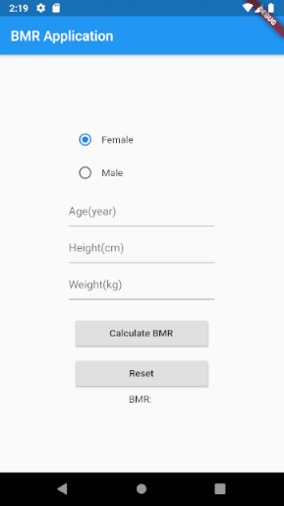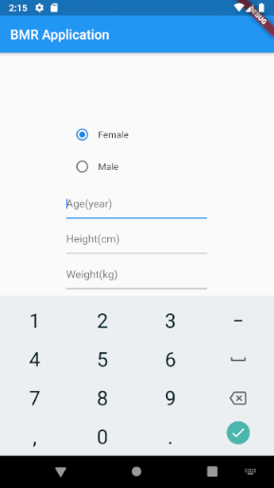

* Input

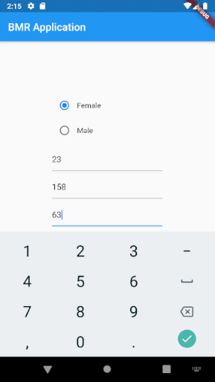

* Output

